1. **Exceeding the boundaries of a single screen**

* In order to view the entire dashboard, you must scroll down the page as the graphs at the bottom are otherwise not visible. This prohibits you from being able to see all the information at once.
* To change, this I adjusted the size on the left hand side of the screen from Custom to Automatic:

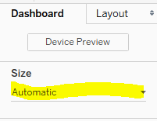

1. **Supplying Inadequate Context for the Data**

* One of the biggest problems with this dashboard is that there is no context for most of the graphs – some graphs show only year of data, while others show multiple years at the same time.
* To address this issue, I added a filter to every worksheet which only looks at campaigns launched after 4/1/2009, and then added a filter for year of launched which I then added to the dashboard. This filter will allow the user to click multiple years at a time, or one year only and see the desired trends.

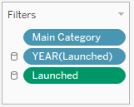The green filter filters for all dates after 4/1/2009 on all sheets. The blue filter is also applied to all sheets and allows the user to select the year.

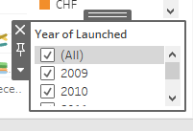I also added this filter to the dashboard so that the user can select what years they want to see.

1. **Displaying excessive detail or precision**

* The table that displays each campaign, the number of backers, the goal dollar amount and the pledged dollar amount went out to four decimal places, even for the number of backers which is a whole number.
* To address this, I formatted the number of backers to an integer format, and the goal and usd pledged amounts to currency in the thousands. This allows for a quick acknowledgement of how the campaign is doing.

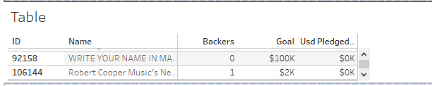

1. **Expressing Measures Indirectly**

* An example of measures being expressed indirectly was the Goal Vs. Pledged tile which was showing goal dollars as one line and pledged dollars as another. This led to the user having to determine the variance for themselves.
* To correct this, I created a new measure called variance of goal v pledged which takes the goal amount and subtracts the goal amount from the pledged amount. This shows the viewer that the campaigns are below their goals.

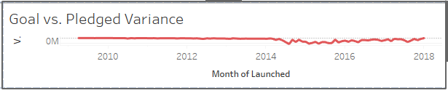

1. **Choosing inappropriate media of display**

* The Category chart which was previously a bubble chart, provided no real information. The only thing that was easily discerned was that the category of product design had the most backers. There were a lot of smaller categories where you could not see any information, and it made comparisons between categories nearly impossible.
* To rectify this, I changed the chart type to a bar chart and sorted in descending order. Now you can more easily see which categories are largest or smallest.

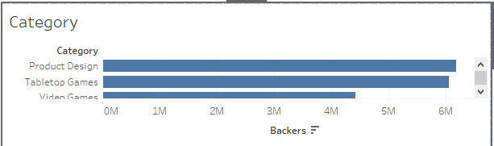

1. **Introducing meaningless variety**

* The Kickstarter dashboard was originally filled with many types of graphs. This distracts the viewer from what is important because they spend times trying to identify what is going on in each graph.
* Part of this was addressed in step 5 by changing the Category graph to a bar chart. I also in this step made the currency graph into a bar chart as well because the information is just as easily digested in that format.

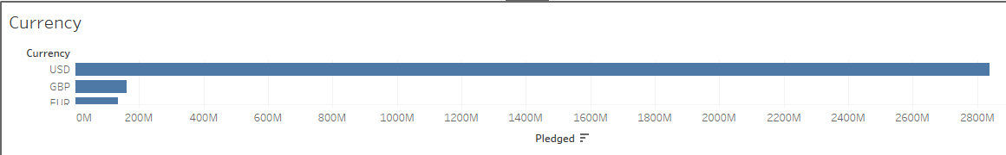

1. **Using poorly designed display media**

* There were many graphs that were poorly designed – the bubble chart for category was poorly designed but has already been fixed. The chart I fixed for this point was the Launched Month line chart. There were too many lines present to really be able to discern any information.
* I switched this to a horizontal stacked bar chart which displays the information more cleanly.

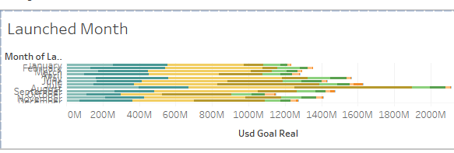

1. **Encoding Quantitative Data Inaccurately**

* The Table that displays each campaign previously brought each measure out to four decimal points which was misleading for multiple reasons – backers should be a whole number because you cannot have .5 backers, for example. Furthermore, the goal and pledged amounts which are dollars were not coded as such which was distracting. This was fixed above as I changed the format of each of the measures.
* The dual axis on the goal vs pledged graph was also misleading and was fixed above when I created a variance graph that uses only one axis.

1. **Arranging the data poorly**

* It is important to arrange the data so that everything can be seen, and in a way that draws attention to what you want the viewer to take away.
* I rearranged the tiles to put graphs in positions where they would be more visible without words cutoff, and where the scale makes sense.

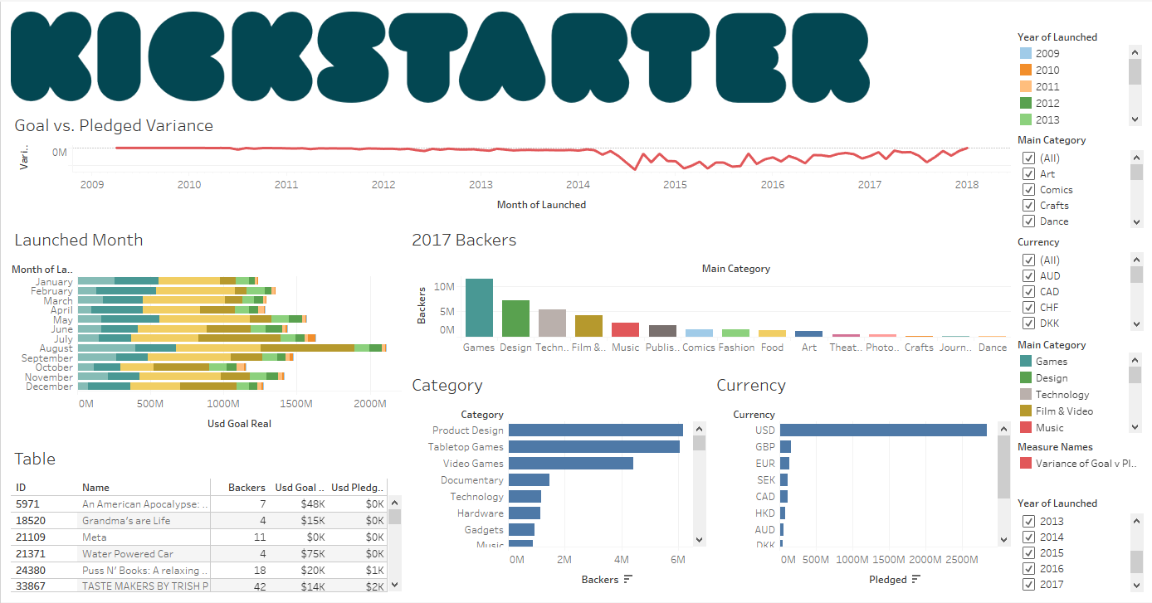

1. **Ineffectively highlighting what’s important**

* Many of the charts were similar in size and had multiple colors present. This was leading to the eye being drawn to many places at once which would cause the viewer to be distracted from what is important.
* I switched the main category graph to be blue and changed the launched month to be blue as well. This left only one graph in red which shows how the campaigns are doing vs what their goals were. I also decreased the sizes of the headers and labels within the tiles which helps maximize data ink and reduce chart junk.

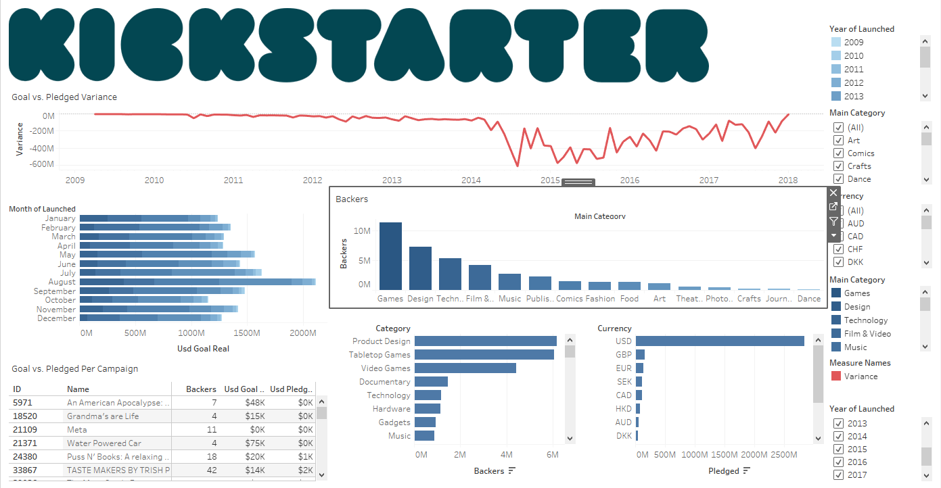

1. **Cluttering the screen with useless decoration**

* The Kickstarter logo which appeared very large at the top of the screen was a bit of useless decoration. There were also legends that were unnecessary such as the legend for variance.
* I made the logo smaller and removed the variance legend. I also moved the year of launched legend to the month of launched graph to give that graph more meaning and allow more space on the right-hand side of the dashboard for the filters that the user can use.

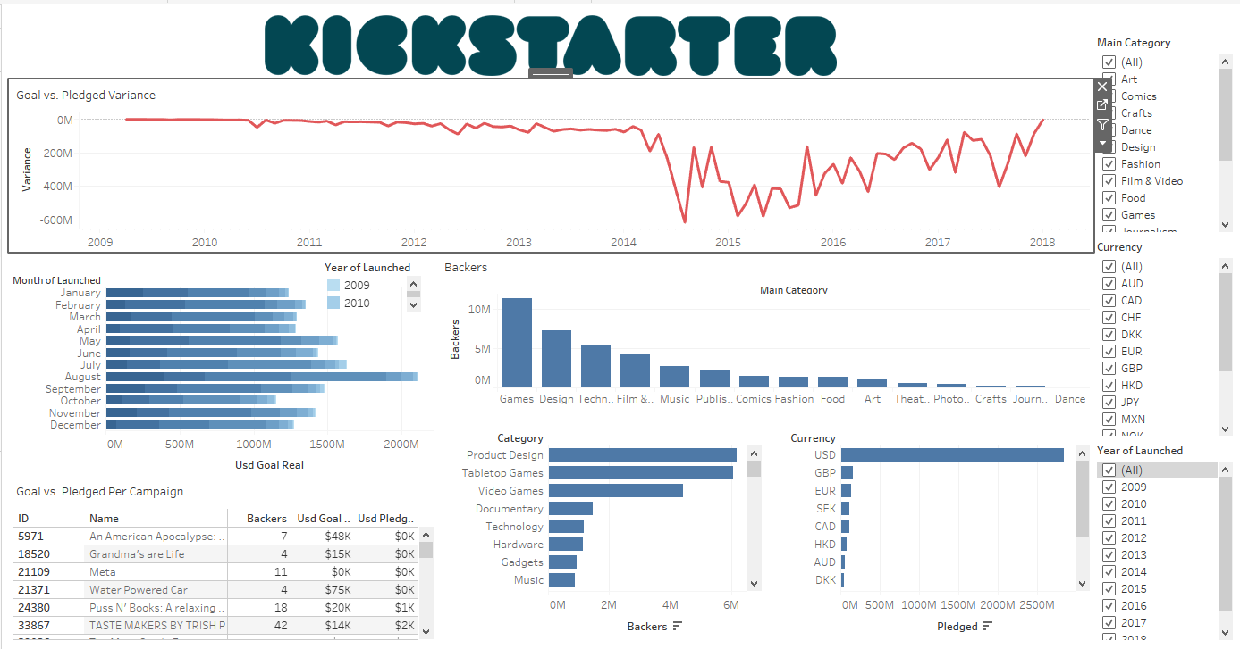

1. **Misusing or overusing color**

* There were multiple colors present on the original dashboard which distracted the user from the messaging.
* To combat this, as shown in the screenshot for number 11, the colors have been muted to mostly solid blue or shades of blue where variation in color was needed. The goal vs pledged chart was left in red because it shows a negative variance which I deemed to be an important message.

1. **Designing an unappealing visual display**

* The original dashboard had a multitude of white space, overused color, and was too busy – there were too many filters on the right-hand side and the header was too large.
* The chosen colors were also visually unappealing.
* These issues have all been addressed in the previous points.